There is no default e2e testing framework in Angular

End-to-End (E2E) testing in Angular using **Playwright** involves automating the testing of your app from the perspective of a real user, ensuring that everything works as expected from start to finish. While Angular typically uses **Protractor** for E2E testing (deprecated from v11), Playwright is a popular alternative that offers fast, reliable, and cross-browser testing capabilities.

<https://angular.dev/tools/cli/end-to-end>

<https://playwright.dev/>

ng e2e (in angular 17)

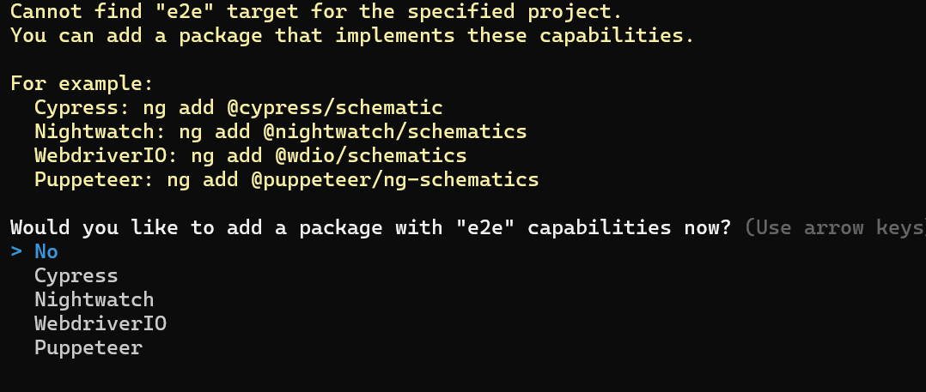

Ng e2e (in angular 19)

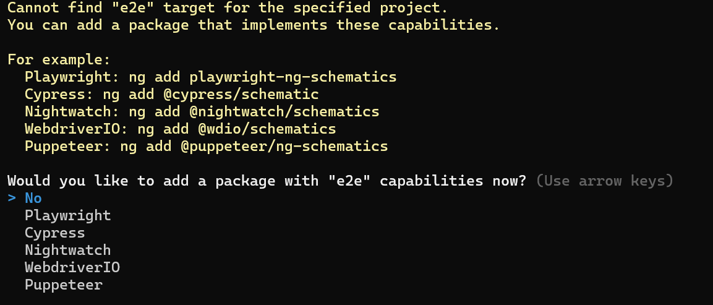

**ng add playwright-ng-schematic**

[**https://angular.dev/tools/cli/end-to-end#setup-e2e-testing**](https://angular.dev/tools/cli/end-to-end#setup-e2e-testing)

Playwright tests and Angular tests should run separately since Playwright only focuses on end-to-end (E2E) testing, and unit tests in Angular need a proper test runner (like Jasmine/Karma).

Make sure that your **unit tests** and **E2E tests** are in separate directories so that Playwright doesn't accidentally pick up the unit test files.